NeuroFleetX – AI Powered Urban Fleet & Traffic Intelligence

INFOSYS SPRINGBOARD VIRTUAL INTERNSHIP 6.0
JAVA BATCH 7 – TEAM B
-NARMADHA L
MY ROLE - Admin module

Agenda:

1.Introduction
2. Problem Statement
3. Objectives of the Project
4. Scope of the Project
5.Deliverables
6.User Roles and Responsibilities
7. Functional Modules
8. Technology Stack Used
9. Milestones and Project Progress
Milestone 1
Milestone 2
Milestone 3
10. Results and Outputs
13.Conclusion

1. Introduction
NeuroFleetX is an AI-powered fleet and traffic management system designed to manage vehicles and monitor traffic conditions in a smart way. The project helps administrators and managers understand what is happening on the road by using dashboards, alerts, and analytics.
It also helps drivers by providing useful trip and traffic information. This system aims to make traffic management more efficient and organized.

2. Problem Statement
With the rapid increase in vehicles, managing traffic and fleet operations has become very challenging. Traditional systems are mostly manual and do not provide real-time insights.
They fail to detect traffic congestion early, identify risk zones, or notify users about important issues. Hence, there is a need for a smart system that can monitor vehicles, analyze traffic data, and provide alerts and insights in real time.

3. Objectives of the Project
The main objectives of this project are:
- To monitor fleet vehicles in real time
- To display traffic and vehicle data in a clear dashboard
- To manage vehicles efficiently
- To generate alerts for traffic and system issues
- To analyze traffic risk using basic AI logic
- To support better decision-making for traffic management

4. Scope of the Project
The scope of NeuroFleetX includes:
- Managing vehicles and their status
- Displaying real-time traffic information
- Identifying and categorizing risk zones
- Providing alerts and analytics
- Supporting three user roles: Admin, Manager, and Driver
The project mainly focuses on frontend visualization and backend data handling with basic AI-assisted logic.

5. Deliverables
The project delivers:
- A working web application
- Role-based dashboards (Admin, Manager, Driver)
- Vehicle management features
- Alert management system
- AI analytics dashboards for traffic risk
- Visual charts and indicators for better understanding

6. User Roles and Responsibilities
- Admin: Manages the system, vehicles, users, dashboards, alerts, and analytics
- Manager: Monitors traffic data, risk zones, and fleet status
- Driver: Views trips, vehicle status, routes, and alerts
Each role has specific access and responsibilities based on system needs.

7. Functional Modules
The system consists of the following functional modules:
- Authentication module for secure login
- Dashboard module for visual monitoring
- Vehicle management module
- Alerts module for notifications
- AI analytics module for traffic risk analysis

8. Technology Stack Used
- Frontend: React
- Backend: Spring Boot
- Database: MySQL

9. Milestones and Project Progress
Milestone 1 – 50%
Completed Modules & Features
1. Dashboard
Admin Dashboard
The Admin Dashboard provides a centralized overview of fleet and system status.
Implemented Features
*Vehicle Statistics Section
  - Total Vehicles
  - Active Vehicles
  - Idle Vehicles
- Stuck Vehicles
*System Health – Congestion Level
  - Displays overall congestion status as:
LOW
MEDIUM
HIGH
  - Color-coded indicators for quick understanding
*Fleet Status Pie Chart
  - Visual breakdown of:
    - Active
    - Idle
    - Stuck vehicles
  - Implemented using Recharts
*Vehicle Type Bar Chart
  - Comparison between:
    - Human-Driven Vehicles
    - Autonomous Vehicles
*Risk Zone Overview
  - List of locations categorized as:
    - Critical
    - High
    - Medium
    - Low
  - Helps administrators identify high-risk areas quickly

2. Vehicle Management Module
Vehicle Management is fully functional and tightly integrated with dashboard analytics.
Implemented Features
- Add Vehicle
  - Register new vehicles with relevant details
- Update Vehicle
  - Modify vehicle information and operational status
- Delete Vehicle
  - Remove vehicles from the system
- Fetch All Vehicles
  - Display all registered vehicles in a structured format
- Analytics Integration
  - Vehicle data is used to calculate:
    - Active / Idle / Stuck counts
    - Fleet status charts
    - Dashboard statistics
Milestone 3 – 100%
implemented the Alerts Page
-> Display all alerts in one page
*Show alert details:
- Type
- Severity (Low / Medium / High / Critical)
- Description
- Vehicle (if any)
- Status (Pending / Resolved)
*Color-coded severity:
- Green → Low
- Yellow → Medium
- Orange → High
- Red → Critical
- Search alerts by type, description, or vehicle
- Create new alerts using a form
- Resolve alerts with one click

implemented the AI Analytics
->The AI Analytics page shows traffic risk information in a simple visual way.
1. Risk Zone Summary
- Shows total number of:
  - Low risk zones
  - Medium risk zones
  - High risk zones
- Displayed using colored cards
- Helps quickly understand overall traffic safety
2. Risk Level Charts
The system shows traffic risk using charts:
- Bar Chart
  - Shows count of Low, Medium, and High risk zones
- Pie Chart
  - Shows percentage of each risk level
These charts make traffic analysis easy and clear.
3. Risk Zone List
- Displays all locations marked as risk zones
- Each location shows:
  - Location name
  - Vehicle density
  - Risk level (Low / Medium / High)
- Uses color tags and icons for better understanding
4. AI-Based Risk Logic (Basic)
- Risk levels are decided using traffic density
- Based on simple AI logic:
  - Low density → Low risk
  - Medium density → Medium risk
  - High density → High risk
- Data is fetched from backend AI APIs
This is a basic AI analytics implementation and can be improved in future.

10. Results and Outputs
- Dashboard showing vehicle and traffic overview
- Vehicle management screens with add, update, and delete options
- Alerts page with severity levels
- AI analytics page displaying traffic risk using charts
- Improved visibility of traffic and fleet data
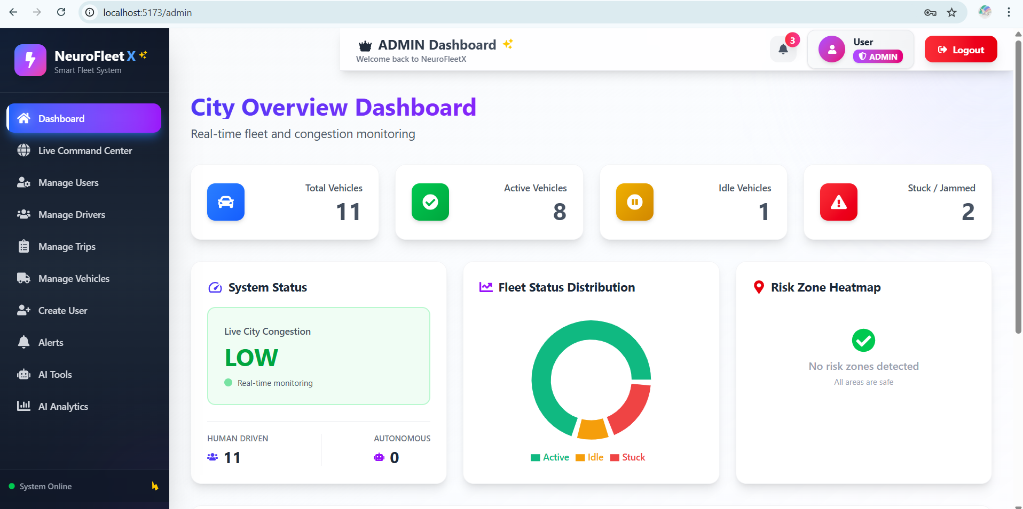
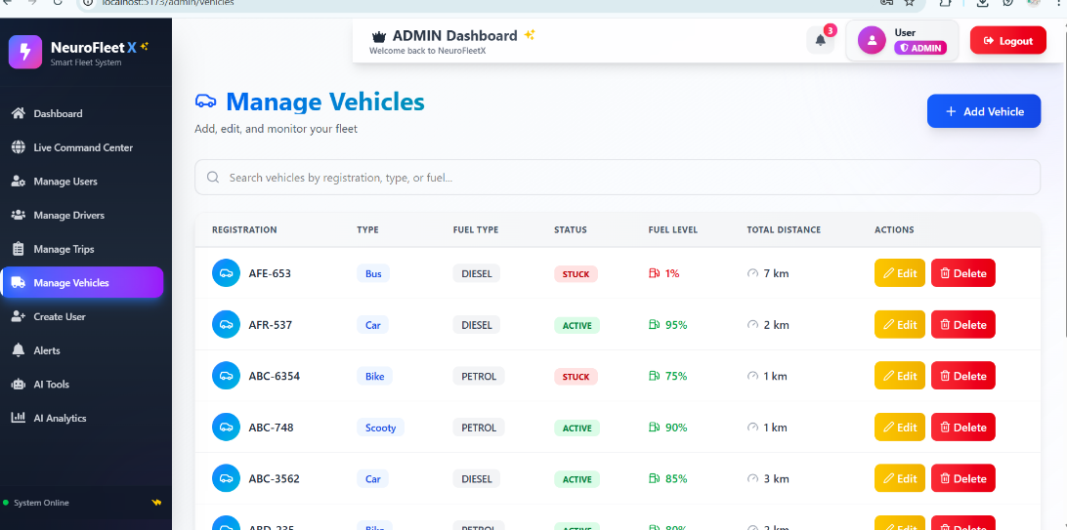
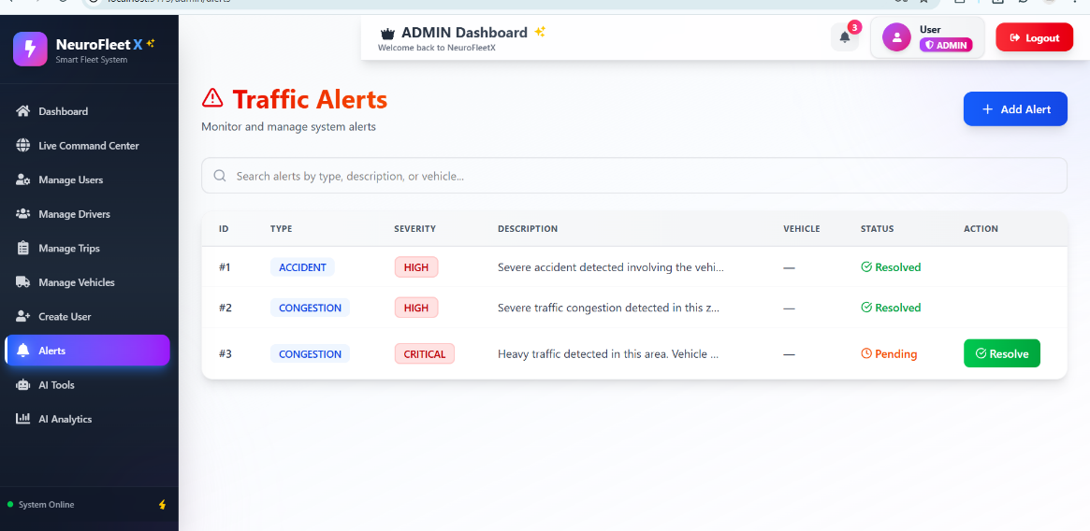

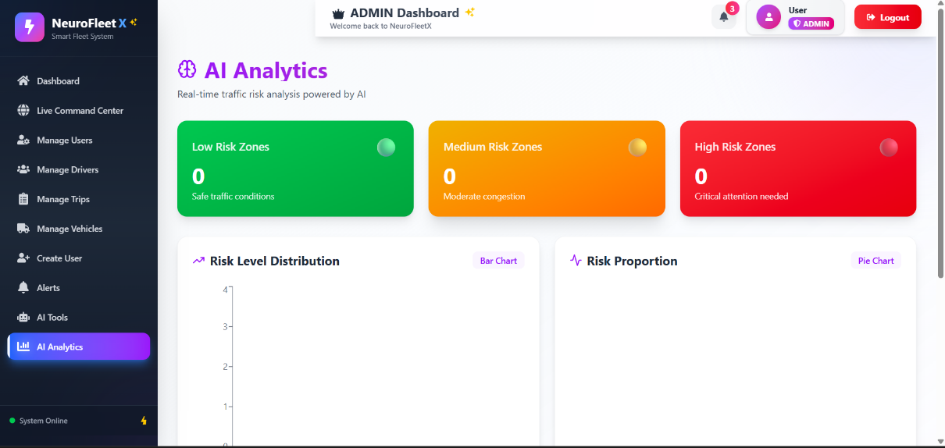

13. Conclusion
In conclusion, NeuroFleetX successfully demonstrates a smart fleet and traffic management system. The dashboard, vehicle management, alerts, and AI analytics modules provide clear insights into traffic conditions and fleet status. This project helped in understanding real-time data handling, frontend visualization, and basic AI-assisted analytics, and it can be further enhanced with advanced AI and machine learning features in the future.

